Regression
This example teaches you how to run a linear regression analysis in Excel and how to interpret the Summary Output.
Below you can find our data. The big question is: is there a relation between Quantity Sold (Output) and Price and Advertising (Input). In other words: can we predict Quantity Sold if we know Price and Advertising?
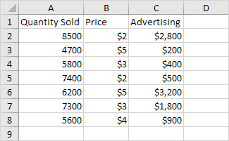
1. On the Data tab, in the Analysis group, click Data Analysis.
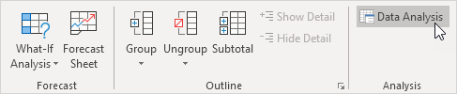
Note: can't find the Data Analysis button? Click here to load the Analysis ToolPak add-in.
2. Select Regression and click OK.
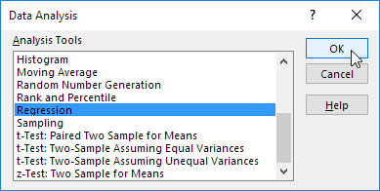
3. Select the Y Range (A1:A8). This is the predictor variable (also called dependent variable).
4. Select the X Range (B1:C8). These are the explanatory variables (also called independent variables). These columns must be adjacent to each other.
5. Check Labels.
6. Click in the Output Range box and select cell A11.
7. Check Residuals.
8. Click OK.
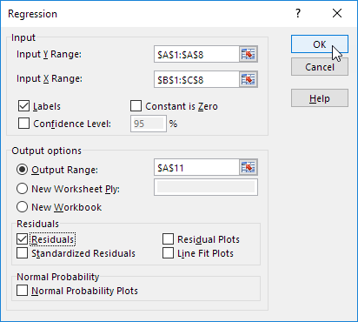
Excel produces the following Summary Output (rounded to 3 decimal places).
Basically, it splits the sum of squares into individual components that give information about the levels of variability within your regression model:
- df is the number of the degrees of freedom associated with the sources of variance.
- SS is the sum of squares. The smaller the Residual SS compared with the Total SS, the better your model fits the data.
- MS is the mean square.
- F is the F statistic, or F-test for the null hypothesis. It is used to test the overall significance of the model.
- Significance F is the P-value of F.
- Adjusted R Square used if more than one x variable
- Observations is the number of observations used in the regression (n)

R Square
R Square equals 0.962, which is a very good fit. 96% of the variation in Quantity Sold is explained by the independent variables Price and Advertising. The closer to 1, the better the regression line (read on) fits the data.
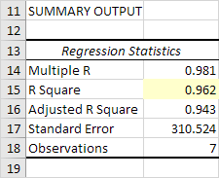

Significance F and P-values
To check if your results are reliable (statistically significant), look at Significance F (0.001). If this value is less than 0.05, you're OK. If Significance F is greater than 0.05, it's probably better to stop using this set of independent variables. Delete a variable with a high P-value (greater than 0.05) and rerun the regression until Significance F drops below 0.05.
Most or all P-values should be below 0.05. In our example this is the case. (0.000, 0.001 and 0.005).
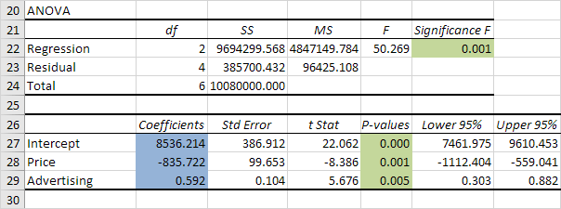

Coefficients
The regression line is: y = Quantity Sold = 8536.214 -835.722 * Price + 0.592 * Advertising. In other words, for each unit increase in price, Quantity Sold decreases with 835.722 units. For each unit increase in Advertising, Quantity Sold increases with 0.592 units. This is valuable information.
You can also use these coefficients to do a forecast. For example, if price equals $4 and Advertising equals $3000, you might be able to achieve a Quantity Sold of 8536.214 -835.722 * 4 + 0.592 * 3000 = 6970.

Residuals
The residuals show you how far away the actual data points are from the predicted data points (using the equation). For example, the first data point equals 8500. Using the equation, the predicted data point equals 8536.214 -835.722 * 2 + 0.592 * 2800 = 8523.009, giving a residual of 8500 - 8523.009 = -23.009.
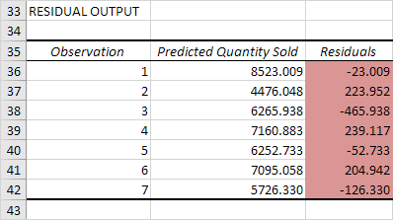
You can also create a scatter plot of these residuals.
